Lesson 4.4 – Two-Way Frequency Tables
Introduction
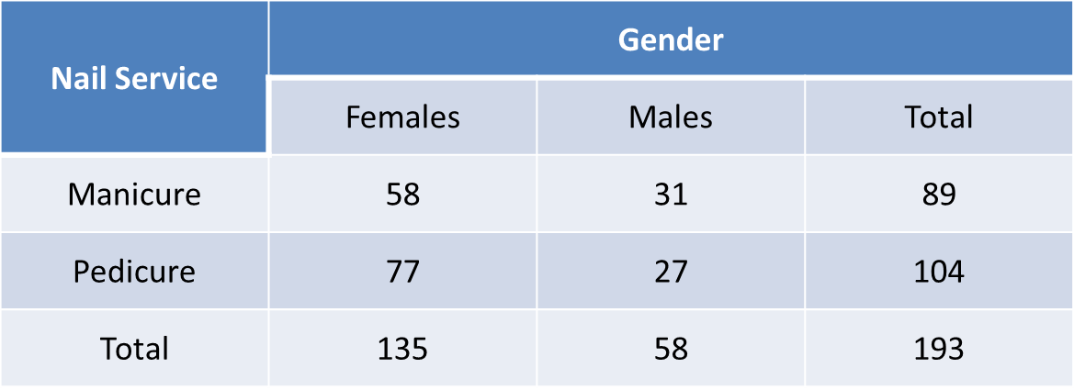
A _____-______ ____________ ______ is a table of data that compares two variables (___________). It separates responses by a characteristic of the respondents.
Example 1:

Vocabulary
A _________ ____________ is the number of responses for a given characteristic.
- The _______ ___ ____ ______ of a two-way frequency table are joint frequencies.
- In our table above, _____, _____, _____, and _____ are each joint frequencies.
A ____________ ____________ is the total number of times a response was given, or the total number of respondents with a given characteristic.
- This is the _______ of either a _____ or a __________ in a two-way frequency table.
- In our table above, _____, _____, _____, and _____ are all marginal frequencies.
A ___________ _________ _____________ expresses a number of responses as a percentage of the total number of responses.
- It allows a ____________ to be made for multiple responses in a single row, single column, or table.
- They are found by ________ the number of responses by the total number of responses.
C.R. Freq. - Service
C.R. Freq. - Gender
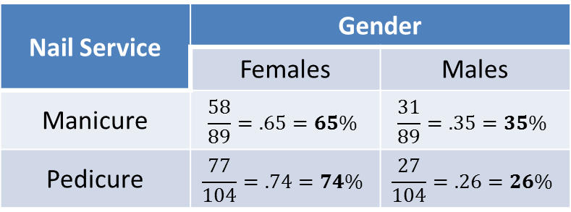
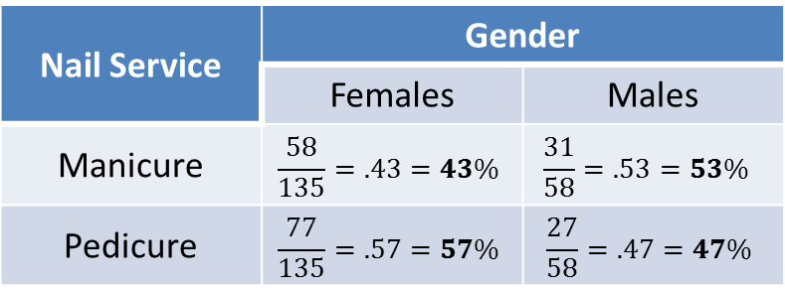

C.R. Freq. – Total People
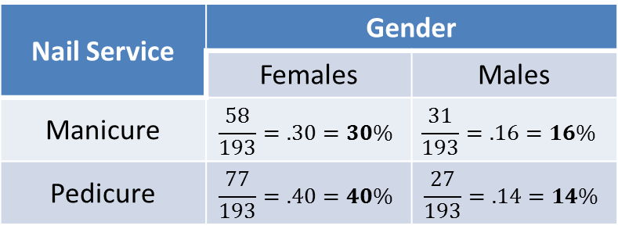

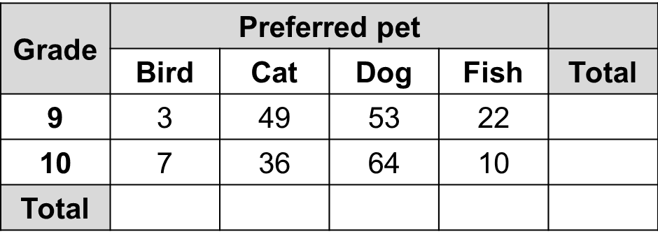
Example 2:
Abigail surveys students in different grades,
and asks each student which pet they prefer.
Their responses are in the table to the right.

- How many 9th graders preferred fish? _________

- What does the joint frequency 7 represent? ________________________________

- What is the joint frequency of 9th graders who preferred cats? _________

- Which pet was the most popular among all the students surveyed? ___________

- Complete the marginal frequencies for each type of pet and for each grade level. Which one is the smallest? __________

- How many students are represented in the survey? _________

- What would the conditional relative frequency be for 9th graders who preferred cats (with respect to 9th graders)? ____________

- What would the conditional relative frequency be for fish (with respect to everyone surveyed)? _____________

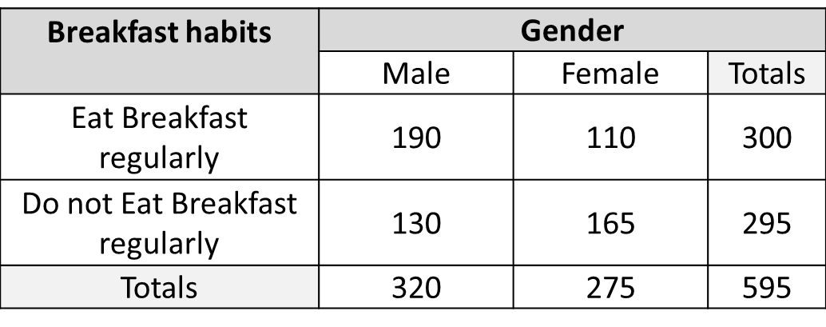
Example 3:
Deshaun surveyed the seniors at his high
school to find out who eats and doesn’t
eat breakfast regularly. Their responses
are in the table at the right.

- How many females “eat breakfast regularly”? ________
This is a ____________ frequency

- 275 is a _____________ frequency. It represents ___________________________.

3. How many people were included in this survey? ________

- Complete the table by calculating the conditional relative frequencies with respect to
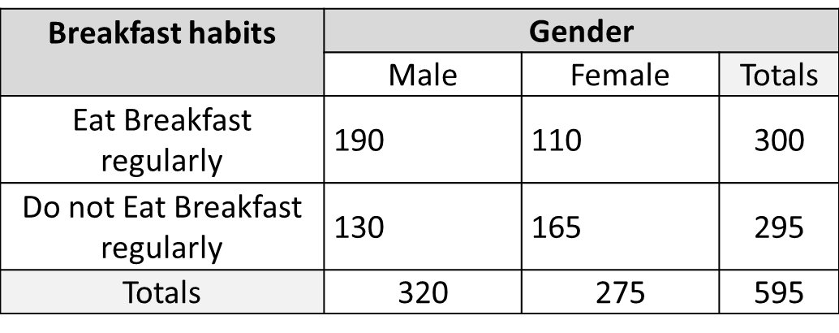
gender.

- What can you conclude about the breakfast habits of males and females?
_______________________________________________________
_______________________________________________________

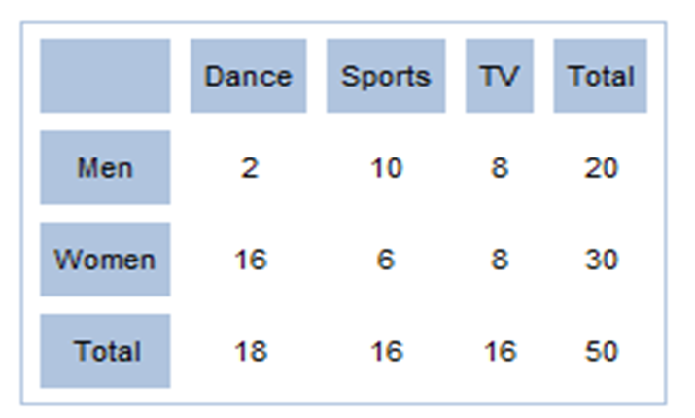
You Try:
Use the Two-Way Frequency table to the right
to answer the following questions.
- Looking at just the marginal frequencies (row & column totals) what can we conclude about the 3 activities?
A. Dance is way more
interesting.
B. They have roughly equal
appeal.
C. Sports is the least chosen
activity.
D. TV is the preferred activity.

2. Looking at the joint frequencies we see that women show a strong preference for which
activity? _________________
- What are the conditional relative frequencies (for both gender and hobby) for men who showed a preference for Sports?

C.R. Freq. for Gender: _____________ C.R. Freq. for Hobby: ____________

