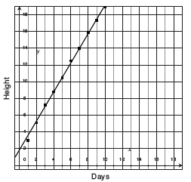
Intro
Pablo’s science class is growing plants. He recorded the height of his plant each day for 10 days. The plant’s height, in cm, over time is in the scatter plot.

(If linear, complete)
Slope value: ____ Slope units: ______________per________________
Slope Interpretation: _____________________________________________________
Y-intercept value: ____ Y-intercept unit: _____________
Y-intercept Interpretation: _________________________________________________
Example 1
A weather team records the weather each hour after sunrise one morning in May. The
hours after sunrise and the temperature in degrees Fahrenheit are in the table below.

Hours after sunrise | Temperature in ⁰F
0 | 52
1 | 53
2 | 56
3 | 57
4 | 60
5 | 63
6 | 64
7 | 67

Can the temperature 0–7 hours after sunrise be represented by a linear function? If
yes, find the equation of the function.

Best fit line:
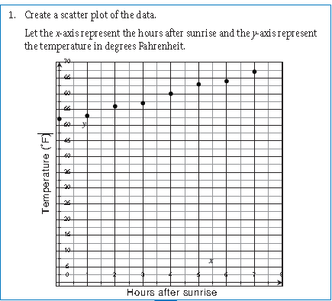

(If linear, complete)
Slope value: ____ Slope units: ______________per________________
Slope Interpretation: _____________________________________________________
Y-intercept value: ____ Y-intercept unit: _____________
Y-intercept Interpretation: _________________________________________________
Example 2:
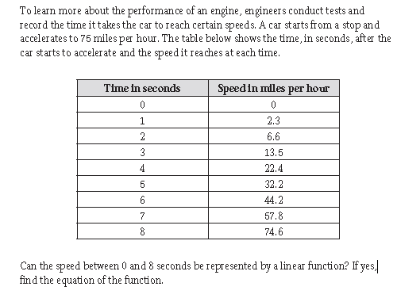

Best fit line:
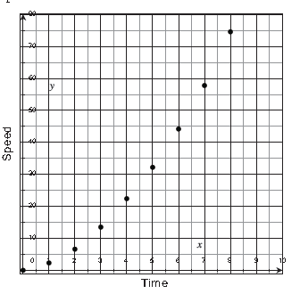

(If linear, complete)
Slope value: ____ Slope units: ______________per________________
Slope Interpretation: _____________________________________________________
Y-intercept value: ____ Y-intercept unit: _____________
Y-intercept Interpretation: _________________________________________________
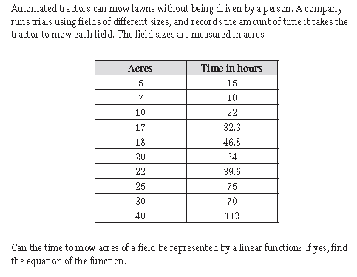
Example 3

Best fit line:
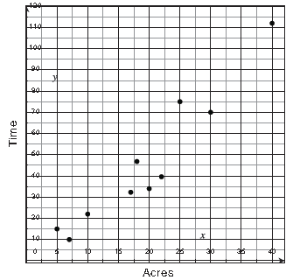

(If linear, complete)
Slope value: ____ Slope units: ______________per________________
Slope Interpretation: _____________________________________________________
Y-intercept value: ____ Y-intercept unit: _____________
Y-intercept Interpretation: _________________________________________________

