**Lesson 4.6 – Best Fit Line Homework**

**#1-6** Decide if the data in each scatter plot follow a linear pattern. If they do, find the equation of the trend line.

1. 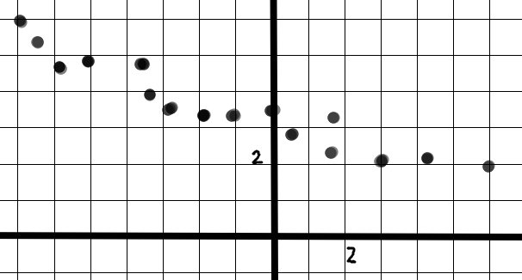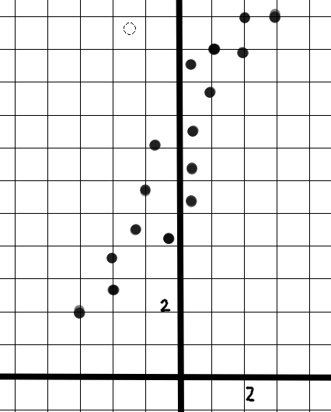 2.

_______________________ _______________________ _______________________



**4.**

**5.**

**6.**

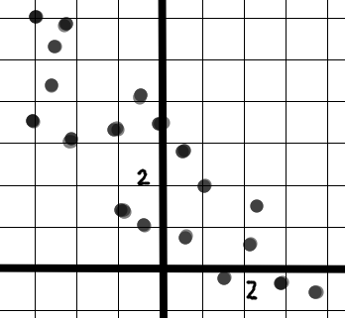

_______________________ _______________________ _______________________

**7. Plot the points and draw a scatter plot. Write the equation of the trend line.**



_______________________