**Lesson 4.8 – Interpreting the Correlation Coefficient and   
Distinguishing between Correlation & Causation**

**Vocabulary**

* A _________________ is a relationship between two events, such as *x* and *y*, where a change in one event implies a change in another event.
* The _____________________ _______________, *r*, is a quantity that allows us to determine how strong this relationship is between two events. It is a value that ranges from –1 to 1.

**Correlation Coefficient (r-value)**

**________ ________ ________ ________ ________**

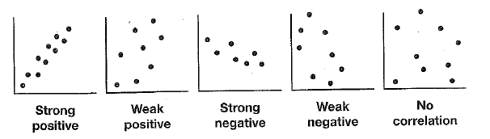

**Correlation vs. Causation**

* Correlation does not imply ________________, or that a change in one event causes the change in the second event.
* If a change in one event is responsible for a change in another event, the two events have a ______________ relationship, or **causation**.
* ______________ factors may influence and explain a strong correlation between two events.

******Let’s Practice!** For each scatter plot identify the correlation type and coefficient.

Correlation

type: _________________

Coefficient: _________

Correlation

type: _________________

Coefficient: _________

Correlation

type: _________________

Coefficient: _________

**Example 1**



**Test score**

**Books read**

1.

2. Describe the relationship between data.

_______________________________________

3. Correlation coefficient: r ≈ 0.48

4. Describe the strength of the relationship between the

data. _________________

5. Consider the casual relationship between the two events.

_____________________________________________________________________

1.



**Free throw percentage**

**Height in inches**

0

**Example 2**

2. Describe the relationship between data.

_______________________________________

3. Correlation coefficient: r ≈ -0.727

4. Describe the strength of the relationship

between the data. _________________

5. Consider the casual relationship between the two

events. _________________________________________________________________

**You Try!**

1.

2. Describe the relationship between data.

_______________________________________

**Average test score**

3. Correlation coefficient: r ≈ -0.84

4. Describe the strength of the relationship between

the data. _________________

5. Consider the casual relationship between the two events.

**Number of students**

_____________________________________________________________________