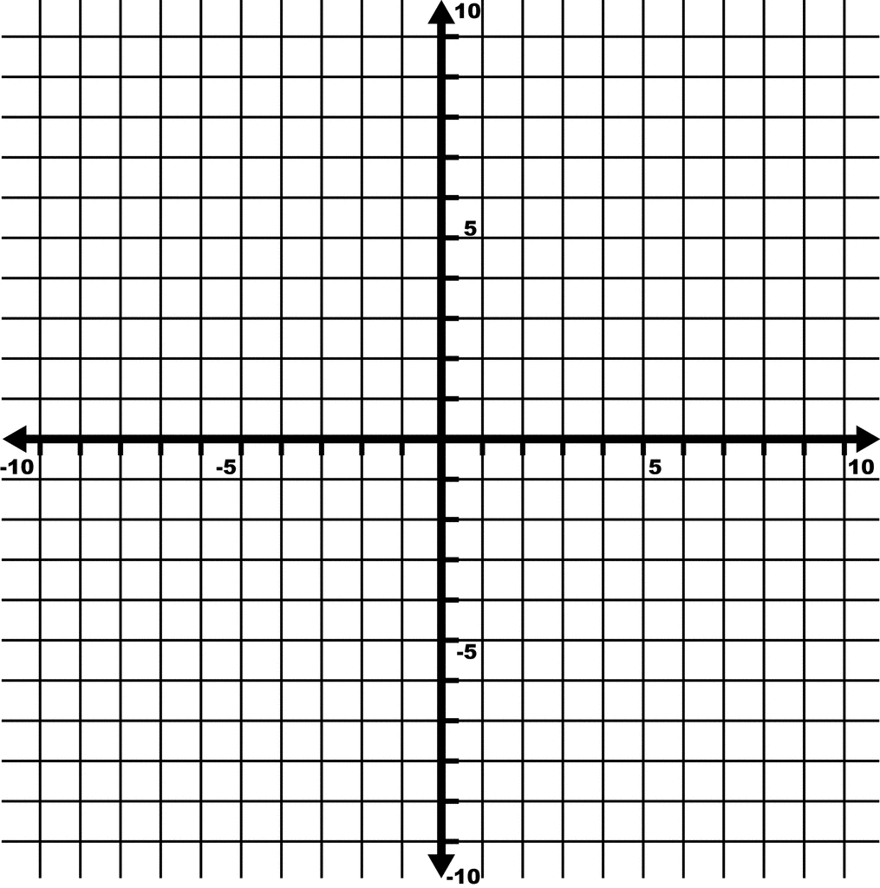
Find the rate of change based off the info in the graph.

Rate of change: ______________

x | y
-2 | 5
-1 | 3
0 | 1
1 | -1
2 | -3
Find the rate of change.

Rate of change: _______________

$$f\left(x\right)=\frac{5}{4}x+2$$
Find the rate of change and y-intercept.

Rate of change: ____________
y-intercept: _______________

$$f\left(x\right)=2x-2$$
Find the rate of change and y-intercept.

Rate of change: ____________
y-intercept: _______________

A car drives 120 miles in 2 hours and 360 miles in 5 hours. What is the car’s rate of change?

Rate of change: ____________

Find the rate of change based off the info in the graph.

Rate of change: ______________
x | y
0 | -3
1 | -2.5
2 | -2
3 | -1.5
4 | -1
Find the rate of change.

Rate of change: ____________

$$f\left(x\right)=-\frac{2}{3}x-4$$

Rate of change: ____________
y-intercept: _______________

x | y
-5 | -10
-4 | -6
-3 | -2
-2 | 2
-1 | 6
Find the rate of change.

Rate of change: _______________

