Unit 3 Review Guide

Write the equation of the following lines:
- A line that passes through the points (3, 4) and (5, -2).
- A line that passes through the points (-7. -9) and (12, 14).
- A line with a slope of ½ and a y-intercept of 6.
- A line with a slope of 2 and that passes through the point (3, 4).
- A line with a slope of ¾ and that passes through the point (-1, -5).
- The equation of the line on the graph below:
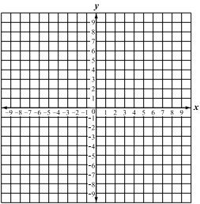
Write the equations that represent the following scenarios:
- Mrs. Jordan’s phone bill decreased by $10 and is now $268.
- Johnathan started a savings account and deposited $200. Each week, he deposits $20 into his account. Write an equation in slope-intercept form that represent the balance of Johnathan’s savings account after x number of weeks.
- Graph the equation y = 4x + 5.

- Write the equation for the table below:
x | Y
-2 | 5
0 | 10
2 | 15
4 | 20
6 | 25

Find the average rate of change for the following situations:
- If Johnathan had started with $500 in his savings account the first week and then he had $700 the fifth week, what would his rate of change be for his savings account?

- Stan is driving to Savannah. He drove 250 miles in 4 hours and 400 miles in 6 hours. What is his average rate of change?
Solve the following equations:
- Tasha joined Get Fit Gym last week. Her initial fee was $50 and she has to pay $25 a month for membership. How much would Tasha pay if she prepaid for a 1-year membership?
- Melissa pays $125 a month for her cable, plus $2 for each movie or game she rents through her On Demand service. How much would she pay this month if she rents 14 movies?

